# GLO-VET Erasmus+ Learning, Teaching and Training week 4 in Finland

16-20 May, 2022

# Objective: Understand how UN SDGs (12-17) are linked to vocational fields of study as well as to personal development as a global citizen

* Share experiences, good practices and learning from each partner college: How are our VET colleges engaging with these goals locally? What is done in Nordic and Baltic countries, and in our towns to promote the achievement of these goals?
* Increase visibility and awareness of UN SDGs locally and within the school
* Include more students and teachers from the host institution work towards the project objectives locally
* Finalise the project end product

# Expected results:

* Improved competences in applying UN SDGs 12-17 in everyday life, and in the vocational profession of students
* Improved competences in transversal skills (21st century skills): entrepreneurial mindset, social, civic, intercultural and language competences, critical thinking and media literacy
* Increased visibility and awareness of the GLO-VET project locally and within the school
* Improved pedagogical content tested during the week with students and teachers from partner countries
* Communication products for the project: Interviews of students, making videos of the week for dissemination

# Sustainable Development Goals 12-17

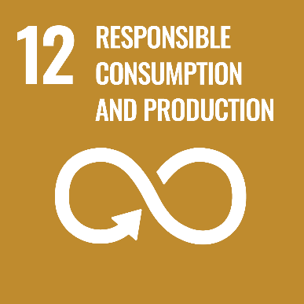  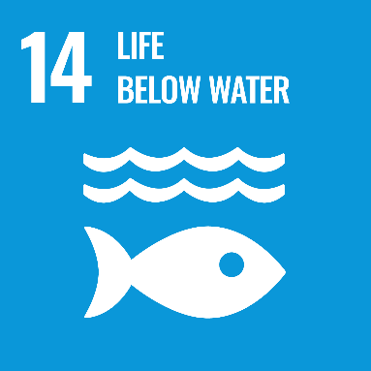

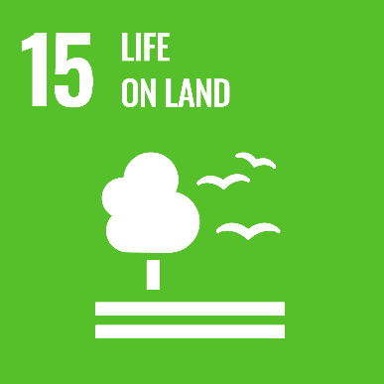  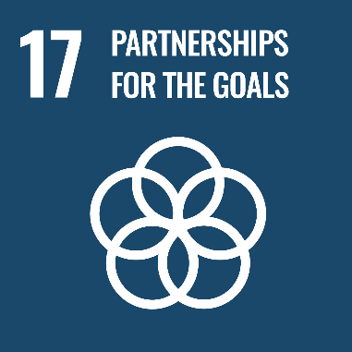

# Participants

* 5 students and 2 teachers from Sweden, Latvia and Finland
* Project coordinators from Finland, Latvia, Sweden and Spain

## Preparatory work for the LTT4 week in Finland

1. **Check the GLO-VET website: what is the project about?** [www.glo-vet.eu](http://www.glo-vet.eu)
2. **Investigate your own clothes closet:** 
   1. How many pieces of different shirts do you have?
   2. Which ones do you wear a lot and for a long time? Why?
   3. How many of the shirts do not use that much? Why?
   4. Why is it important to consider how long you use certain garment, or in what kind of circumstances it has been produced?
3. **Video presentation from NGO Finnwatch on corporate social & environmental responsibility:**

Before the GLO-VET week in Finland, please watch these two videos where researcher Anu Kultalahti from a Finnish NGO [Finnwatch](https://finnwatch.org/f) is talking about their reports on responsibility and sustainability in the fields of construction and textile industry. Her presentation is also attached here with some questions for you to think about.

* How can you identify possible labour exploitation or human rights violations at your workplace?
* How will transition to low-carbon economy impact your work? How to make sure that this transition is "just" for different groups of people?

NGO Finnwatch, Part 1 (22 min):

Password: glovet2022

<https://vimeo.com/705261877>

NGO Finnwatch, Part 2 (17 min):

Password: glovet2022

<https://vimeo.com/705267607>

[Presentation slides from Anu Kultalahti](https://drive.google.com/file/d/1wU2fJ0QdwkpGl6PRk8uYr_kE6JoReIIz/view?usp=sharing)

# Arrival day: Welcome!

## **Monday 16.5.2022**

**Pick up from the Helsinki-Vantaa airport:**

-**Latvian group**: Air Baltic BT 301, klo 10:25, 9 persons > transfer booked from airport **at 11.10** / T2 bus station (Cabline minibus)

- **Swedish group**: Finnair AY0810, arrival at 17:05, 7 persons > transfer booked from airport **at. 18.00** (same transfer as for the ES group)/ T2 bus station (Cabline minibus)

- **Spanish group**: Finnair xx.xx (TBC) from Madrid, arrival 17:25, two, transfer booked from airport **at. 18:00** (same transfer as for the SE group) / T2 bus station (Cabline minibus)

Cabline contact/Janne +358-500 474 636

**Note:** Drive from airport to accommodation takes about 1 hour.

**SETTLING IN AND EVENING PROGRAM**

**13:00 Lunch for Latvia group**

**Riuttaranta staff to go through practicalities within accommodation**

**19-20: Dinner**

**20-21: Free-time / Coordinators’ meeting (program check) + evening snack?**

**Will stay during the night at Riuttaranta Tellervo , Darja ja Anna-Kajsa**

**Sauna (this is voluntary)**

# Day 1: Sustainability & work

## **Tuesday 17.5.2022**

| **Time** | **Topic** | **Responsible** | **Where** |
| --- | --- | --- | --- |
| 08:00 – 08:30 | Breakfast |  | Accommodation |
| 08:45 – 09:15 | Bus to Luksia   * Practicalities (toilets, smoking, cafes, other rules in Luksia etc) | **Jasmin Johnsson with Tellervo (FI) waiting at the Luksia main door**  **Jasmin - practicalities of the week** | Bus company: Taxi-Lady Oy |
| 09:15 – 10:00 | **Start of the week**   * Welcome to Luksia! * Programme for the week * Expectations for the week   + in pairs, writing on post-its | Outi - the week of the program  Riikka - goals for the week and facilitating the expectations for the week | Luksia, Ojakkalantie 2  class B 1.037 |
| 10:00 – 10.30 | **Luksia & sustainability now**   * News from Luksia’s equality and non-discrimination plan   Luksia to think of reflection questions to be discussed in groups of 2-3 ppl  here: participants to share their experiences, what is being done in their school/community around human rights | **Nea Piironen (FI)** |  |
| 10:30 – 11:00 | ***Break*** |  | Luksia’s cafe open; supermarket 100m from the school |
| 11:00 – 11:45 | **Luksia campus walk - students to tell about the responsibility issues in their field**   * LukStore (Tellervo) * Interior artisans (Tellervo) * Construction (Tellervo) * At 11.30 Logistics (Matti Salmi & Toni Tiilikainen, classroom D 128 confirmed) * In 2 groups: Jasmin + Tellervo & Outi & Katjusa | Confirmed |  |
| 11:45 – 12:30 | **Lunch in the student canteen** |  |  |
| 12:30 – 13:30 | **Corporate social & environmental responsibility**  *Anu Kultalahti, researcher, Finnwatch (recording sent beforehand)*   * Finnish construction industry & human rights (SDG 16) * Future of the textile design industry (SDG 12, 13)   Group work on ethical questions in workplaces and industries.  What kind of examples of ethical questions and global justice can you think of in workplaces? (production chains, working conditions etc) | Riikka  Recording + powerpoint from Finnwatch as a pre-task to watch |  |
| 13:30 – 14:00 | ***Break*** |  |  |
| 14:00 – 15:00 | **Esa Parkko: Changing world of work and sustainability**  30 min + 15 min for questions | Outi to meet Esa at the main door 13:30 |  |
| 15:00 – 15:30 | **Wrap-up of the day** | Riikka |  |
| 15:30 – 16:00 | Bus to accommodation |  | Bus company: Taxi-Lady Oy |
| 16:00 – 18:00 | Free time |  |  |
| 18:00 – 19:00 | Dinner |  |  |
| 19:00 – 22:00 | Boardgames, Uno, Skip-bo, Mölkky, Blind square  + evening snack | Lakeside Sauna not available |  |

# Day 2: Nature & Helsinki day

## **Wednesday 18.5.2022**

## 

| **Time** | **Topic** | **Who** | **Where** |
| --- | --- | --- | --- |
| 08:00 – 08:30 | Breakfast |  | Accommodation |
| 09:00 – 10:00 | Bus to Haltia (stop in Nummela) |  | Bus company: Taxi-Lady Oy |
| 10:00 – 12:00 | ***Guided tour in Haltia nature centre at Nuuksio national park, short walk in the nature park***  **Confirmed**  Hinnat: omien oppilaiden pääsyliput á 2,50 € ja vieras oppilaiden á 5 €. Aikuisten á 9 €. Ryhmänjohtaja ja opet maksutta. Opastus 95 €.  Jaana Muhonen, palvelukoordinaattori  040 7796762, jaana@haltia.com | Outi | <https://haltia.com/en/> |
| 12:00 – 13.00 | **Lunch at (Haltia) Solvalla**  Lunch á 10,20 €.  Invoice details and food limitation sent 12.5. [Jimmy.Lindfors@folkhalsan.fi](mailto:Jimmy.Lindfors@folkhalsan.fi)  Tfn: +358 40 166 2385 |  |  |
| 13:00 – 13:45 | **Bus from Haltia to Helsinki city centre** |  |  |
| 14:00 – 16:00 | Taking a look at the Central Library Oodi  <https://www.oodihelsinki.fi/en/>  Voluntary:  An idea: Amos Rex-museum exhibition (Finnish students to show around)  <https://amosrex.fi/en/> | Room reserved (Ryhmätila 2 btw 15 - 18) |  |
| 16:00 - 18:00 | Free time in Helsinki  Walk on your own to Konstan Möljä (15 min walk from the centre) |  |  |
| 18:00 – 20:30 | Dinner at [Konstan Möljä](https://www.konstanmolja.fi/)  Address: Hietalahdenkatu 14  (25€ per person)  Invoice details, food limitations sent 12.5.  [ravintola@konstanmolja.fi](mailto:ravintola@konstanmolja.fi)  +358 9 694 75 04 | Outi | [www.konstanmolja.fi](http://www.konstanmolja.fi) |
| 20:30 – 21:30 | Bus back to accommodation |  | Bus company: Taxi-Lady Oy |

# 

# Day 3: Taking action

## **Thursday 19.5.2022**

| **Time** | **Topic** | **Responsible** | **Where** |
| --- | --- | --- | --- |
| 08:00 – 08:30 | Breakfast |  | Accommodation |
| 08:30 – 09:00  08:15 - 09:00 | Bus 1 to Hawkhil from Riuttaranta  Bus 2 to Hawkhill from Luksia, **via Riuttaranta** |  | Bus company: Taxi-Lady Oy  (2 minibuses) |
| 09:00 – 12:15 | **H**awkhill visit, <https://www.hawkhill.fi/>  9.00-10.15  Learning about their sustainability work   * Visit in the cottage village * Themes: social responsibility, recycling (waste/furniture/water), responsible construction   10.15-11.15  Workshop session on wild herbs and preparing a personal wild herb food bath salt to take home  11.15-12.00  Lunch by the campfire, responsible local food  12.15  Departure  (programme cost per person 32€, exceptional costs could be used to cover this) | Annu / Hawkhill  Katjusa tarkistaa ja ilmoittaa henkilömäärän sinne  OK / 9.5. ilmoitettu 22 hlö ja erik.ruokavaliot. | Hawkhill |
| 12:15-12:45 | Transfer from Hawkhill to Luksia Nummela |  | Bus company: Taxi-Lady Oy |
| 12:45 – 13:45 | * Tellervo: National VASKI project and Ecocompass system - 10 min + 5 min for questions * Outi: new optional courses on sustainability for students – 5 min + 5 min for questions   ***Any ideas from the students, what to do here***  Project work? On the game / results / producing communication work  In our application:  - Presentations and peer feedback from each countries’ activities: Each partner to demonstrate a learning activity or good example on SDGs 12-17 that will be included in the digital  tool  **Coordinators’ transnational meeting**   * Future of the project | OK  **Sonia?** |  |
| 13:45 – 14:00 | ***Break*** |  |  |
| 14:00 – 15:30 | **Municipal collaboration projects (SDG 14, 15)**  Workshop: Henna Björkqvist tel. 045 7884 2810, project manager, Luvy (<https://www.luvy.fi/>)   * Inter-municipal project related to local rivers/water * Something interactive / experiential learning in small groups? * Water situation in the world, clean water | Outi |  |
| 15:30 – 16:00 | **Wrap-up of the day in the form of Instagram posts / short videos in small groups**  **Collection of images to be run from lobby screen** | Tellervo to check with Paula how to share with Luksia screen |  |
| 16:00 – 16:30 | Bus to accommodation |  | Bus company: Taxi-Lady Oy |
| 16:30 – 18:00 | Free time |  |  |
| 18:00 – 19:00 | Dinner |  |  |
| 19:00 – 22:00 | Movie / boardgame night?  + evening snack  BIG vs SMALL -dokumentti Areenassa, <https://areena.yle.fi/1-50645783>  Metsän / Järven / Tunturin tarina? | Tellervo  Sauna available (voluntary) |  |

# Departure day: good-bye!

## **Friday 20.5.2022**

| **Time** | **Topic** | **Who** | **Where** |
| --- | --- | --- | --- |
| 08:00 – 08:30 | ***Breakfast*** |  |  |
| 09:00 – 10:00 | ***Packing your room and check out*** | Outi | At the accommodation |
| 10:00 - 11:00 | **Wrap-up**  **Feedback** | Outi  Riikka to prepare electronic feedback form |  |
| 12:00 or 11:00 (TBC by Katjusa) | Departure (all) |  | Bus company: Taxi-Lady Oy |

# Departure:

# Swedish team at 15.15, Latvia-team at 17:00, Spanish team at xx.xx (TBC)